Uploading Module, Try it, and Challenge Game images to the site

# Overview

The JUICE UI uses images as identifiers for modules, and for mini-lesson Try it and Challenge Game choices.

Module images appear on the JUICE Dashboard, on the pop-ups that display when you launch a specific JUICE module, on the module page, and in the site breadcrumb:

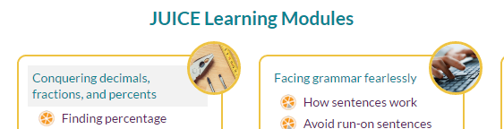

 

The Try it and Challenge Game images appear on the mini-lesson tab “choose” pages:

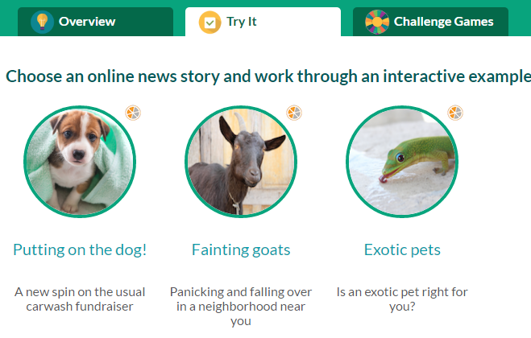 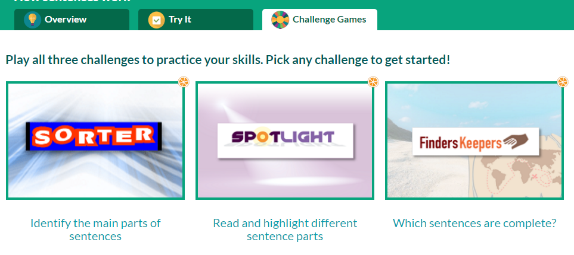

These images live in Amazon S3. Module images live in the module directory, and modulette images live in the directories for each modulette.

The site knows which image to display based on the image file name, and applies both the circular cropping and the borders to the images that you upload.

In an alternate program, JUICE will first look for module and mini-lesson images in the alternate program’s module and modulette directories. If none exist, JUICE will look in the core JUICE module and modulette directories. If no images are found, the site will display placeholder images that looks like this:



## 

## S3 file structure reminder

Module and modulette ids correspond to directory names in S3.

The files for module QS1 are found in the S3 directory QS1.

The files for modulette QS1.1 are found in the S3 directory QS1/1.

Files for alternate (custom) programs are found in the specific alternate program’s directory, which is located in /programs.

# Uploading module images

1. Size your module image to be square and at least 140 x 140 pixels.

JUICE resizes the image and displays it within a yellow circle on the module pop-up, the module page, and the dashboard. It displays as a tiny square in the breadcrumb.   
  
If the image is not square, its aspect ratio will be distorted.

1. Name your module image file as follows:

module.png

This is CASE SENSITIVE. If you do not use this name, the site will not display the image.

1. Locate the module’s directory in S3, and upload your image. For example, if you are uploading an image for module QS11, the S3 directory name is QS11.  
     
   If you are uploading a replacement image or new image for core JUICE, the module directory is in the root of your S3 bucket. If you are uploading an image for an alternate program, look in the /programs/[alt program] directory.

# Uploading Try it and Challenge Game images

1. Make sure your images are the correct sizes and shapes:

|  |  |  |  |
| --- | --- | --- | --- |
| **Image type** | **Shape** | **Size is at least:** | **Display in site** |
| Try it | Square | 140 x 140 pixels | Circle with an outline |
| Challenge Game | Rectangle | 200 x 300 pixels | Rectangle with an outline |

JUICE resizes your images and displays them with a border. The Try it images display inside circles and the Challenge Game images display inside rectangles.

If your image is not the right shape or it is too small, it will be distorted or grainy.

Note: For the Challenge Games, the JUICE standard is to use graphics that include the game name. These graphics are in the *Content authoring / Games* documentation directory

1. Name your image files to match the tracks they display with as follows. This is CASE SENSITIVE. If you do not use these names, the site will not display your images:

Try its:

guided_practice_track_1.png

guided_practice_track_2.png

guided_practice_track_3.png

Challenge games:

challenge_track_1.png

challenge_track_2.png

challenge_track_3.png

1. Locate the modulette’s directory in S3, and upload your image. For example, if you are uploading an image for modulette CS4.2, the S3 module directory name is CS4, and the modulette directory name is 2.  
     
   If you are uploading a replacement image or new image for core JUICE, the modulette directory is in the root of your S3 bucket. If you are uploading an image for an alternate program, look in the /programs/[alt program] directory.